https://help.toponad.com/cn/docs/fRMh7C

Parameters：

App:

Parameter: appId Key: appId Type: Required

Unit:

Parameter: placementId Key: placementId Type: Required

Adapter Path:

RewardVideo: com.td.network.topon.TDToponRewardVideoAdapter

Interstitial: com.td.network.topon.TDToponInterAdapter

Banner: com.td.network.topon.TDToponBannerAdapter

Splash: com.td.network.topon.TDToponSplashAdapter

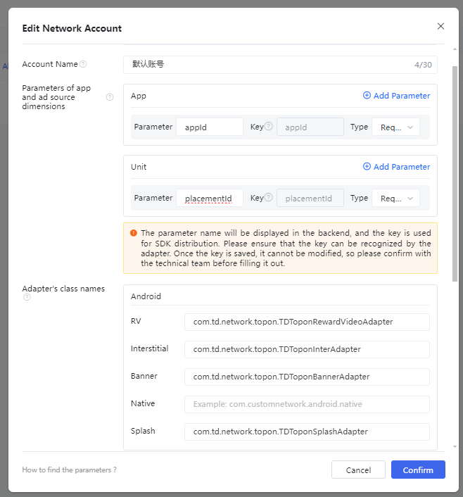

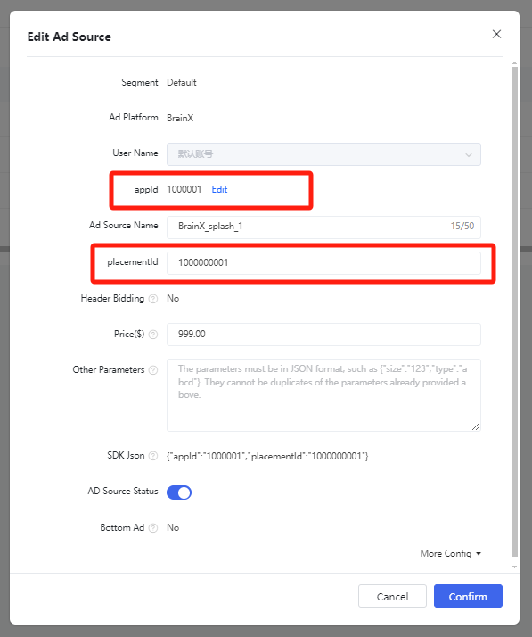

Notice：SDK Proguard rules：  
     -keep class com.td.\*\* { \*; }  
    -keepclassmembers class com.td.\*\* {  
        @com.td.\* public \*;  
    }